Project Report Template

TITLE:CRM APPLICATION THAT HELP TO BOOKS A VISA SLOT

1. **INTRODUCTION**
   1. **Overview**

A visa slot management project is a system that is used to track and manage the availability of visa slots, which are appointments that are required for certain visa applications. It might be used by a slots, which are appointments that are required for certain visa applications. It might be used by a government agency or a visa processing center to schedule and manage appointments with applicants

* 1. **Purpose**

This will help you to track and manage the availability of visa slot , which are appointments that are required for certain visa applications.

1. **Problem Definition & Design Thinking**
   1. **Empathy Map**

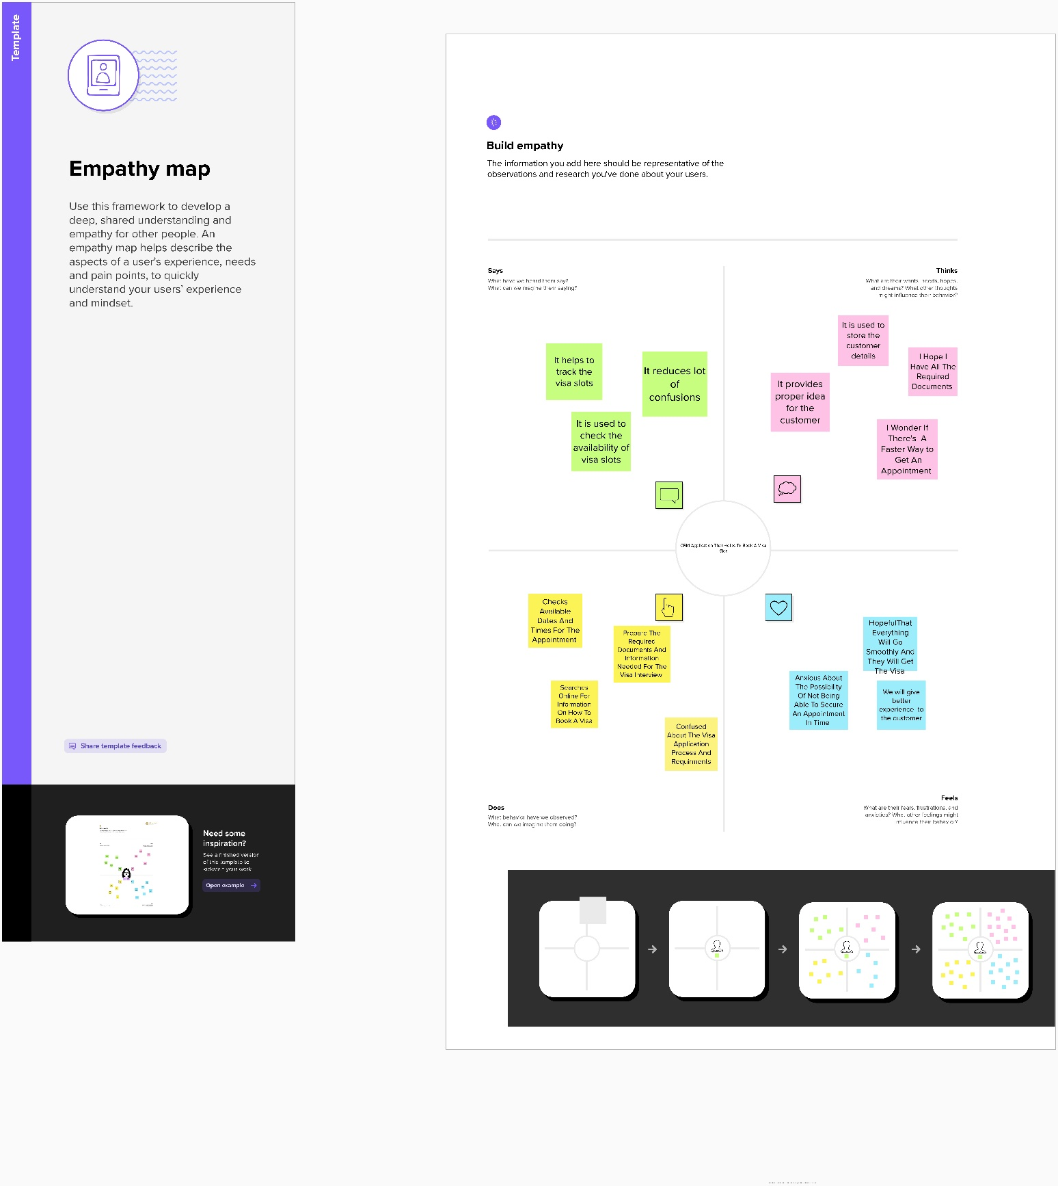

* 1. **Ideation & Brainstorming Map**

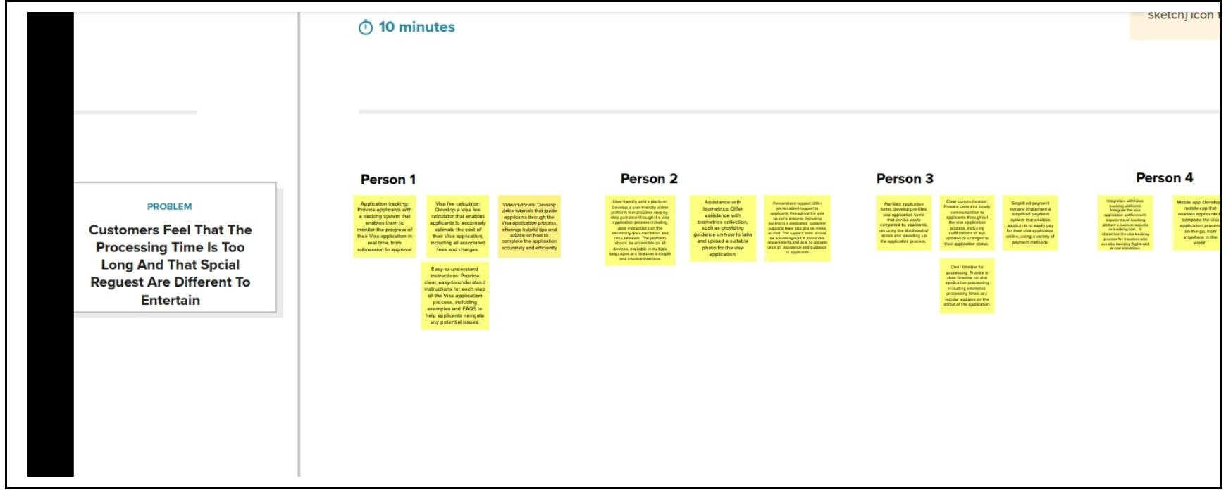

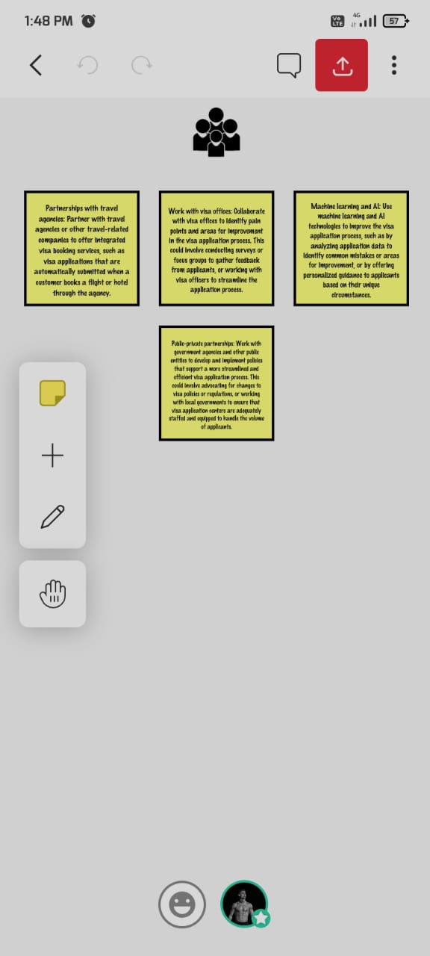

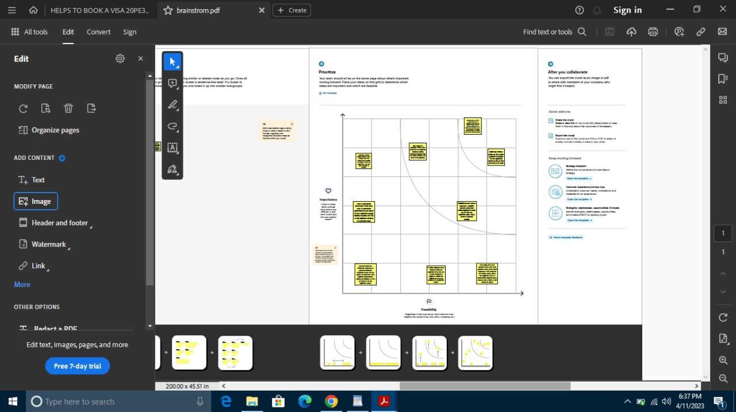

1. **RESULT**
   1. **Data Model:**

|  |  |
| --- | --- |
| **Field Label** | **Data Type** |
| Contact number | Number |
| Full Name | Text |

|  |  |
| --- | --- |
| **Field Label** | **Data Type** |
| Password number | Text |
| Permanent address | Text |

|  |  |
| --- | --- |
| **Object Name** | **Field in the Object** |
| **Obj - 1** |  |
| **Obj - 2** |  |

**Activity & Screenshot**

Attach the screenshots of your project activity along with the description. 4 Trailhead Profile

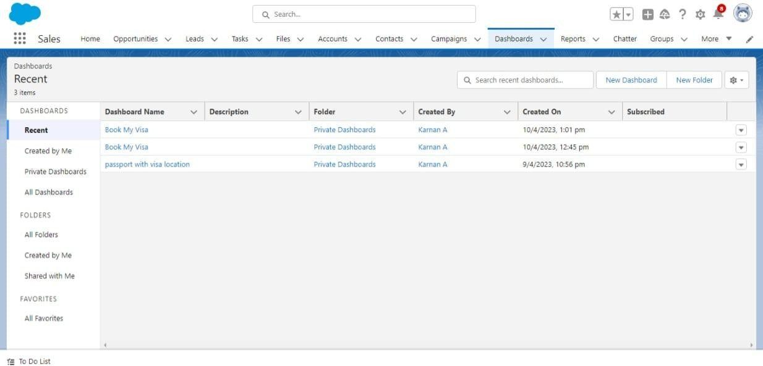

Public URL

1. **Trailhead Profile Public URL**

**Team Lead - https://****trailblazer.me/id/vasak14** **Team Member 1 -** [**https://trailblazer.me/id/karna63**](https://trailblazer.me/id/karna63) **Team Member 2 -** [**https://trailblazer.me/id/vishv100**](https://trailblazer.me/id/vishv100) **Team Member 3 –** [**https://trailblazer.me/id/veerk19**](https://trailblazer.me/id/veerk19)

# ADVANTAGES & DISADVANTAGE

# 

As nouns, the difference between disadvantage and advantage is that disadvantage is a weakness or undesirable characteristic; a con while the advantage is any condition, circumstance, opportunity, or means, particularly favorable to success, or any desired end.

# APPLICATIONS

An application, also referred to as an application program or application software, is a computer software package that performs a specific function directly for an end user or, in some cases, for another application. An application can be self- contained or a group of programs. The program is a set of operations that runs the application for the user.

The areas where this sol ution can be applied

# CONCLUSION

Traditionally, talent technology has consisted of siloed solutions, often involving manual processes. With the Radancy Talent Acquisition Cloud, we offer a single, integrated, end-to-end platform that automates and optimizes the candidate recruitment process – allowing our platform to deliver more effective and cost-efficient outcomes.

Conclusion summarizing the entire work and findings.

# FUTURE SCOPE

The future of CRM is bright. CRM will continue to report key data and give insight for future action, however, leading experts see CRM evolving to measure and inform sales enablement and customer engagement while playing a tremendous role in the success of future business.

Enhancements that can be made in the future.